Vu Anh Huy Nguyen – Assignment 3 IoT
A report:
Opportunities:
IoT applications implemented by Flask APIs supports a range of opportunities across various industries. For instance:
- Smart Cities: Real-time temperature data can contribute to urban planning, energy optimization, and disaster preparedness.
- Climate Monitoring: Temperature sensors provide valuable data for environmental studies and weather forecasting.
- Personal Applications: Users can integrate temperature sensors with home automation systems for comfort and energy efficiency.
Industry Practice: The development of this application aligns with key IoT industry practices. Flask’s RESTful architecture ensures easy integration with various devices and systems, while the application’s ability to fetch real-time temperature data from external APIs represents a standard approach in IoT systems that I got experienced and knowledge from Assignment 1. Additionally, Flask’s lightweight nature allows the application to scale effectively as more sensors are added. Finally, robust error responses enhance reliability and improve user experience.
Challenges: Leveraging the work from Assignment 1 posed significant challenges due to the need to integrate with Flask. Manually adding information to the dictionary made it difficult to update new data dynamically. Therefore, I enhanced the application by incorporating API configurations and adding coordinates for the regions where I wanted to fetch the current temperature in Celsius. However, fetching real-time data may introduce delays, especially when API responses are slow.

@ POSTMAN screenshot
GET /sensor:
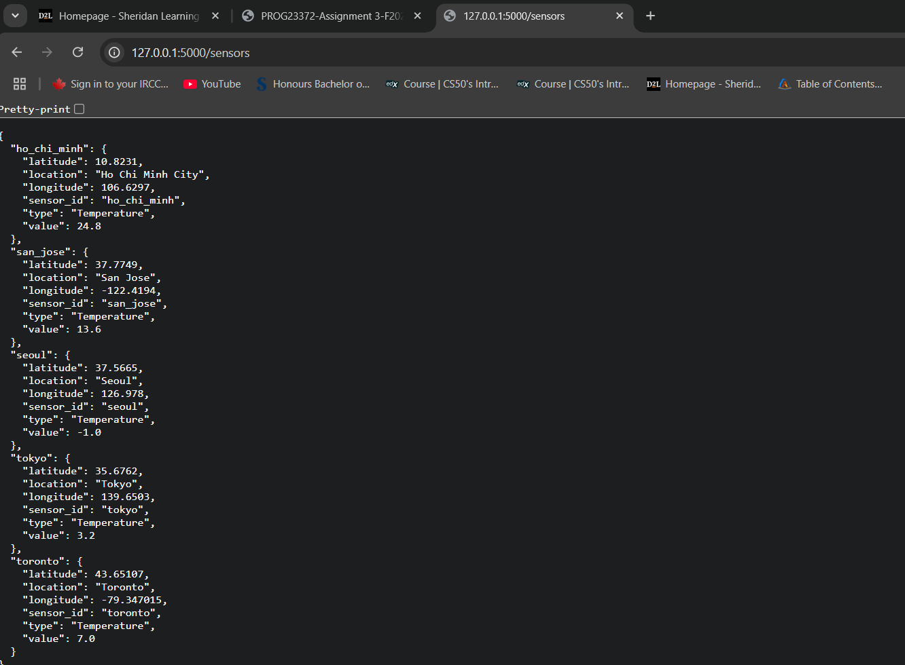
GET /sensors/<sensor_id>
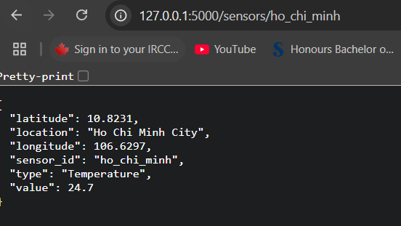
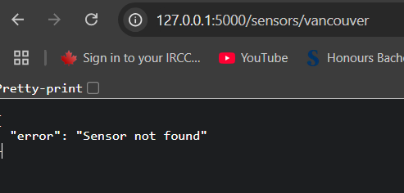
GET /sensors?type=<sensor_type>
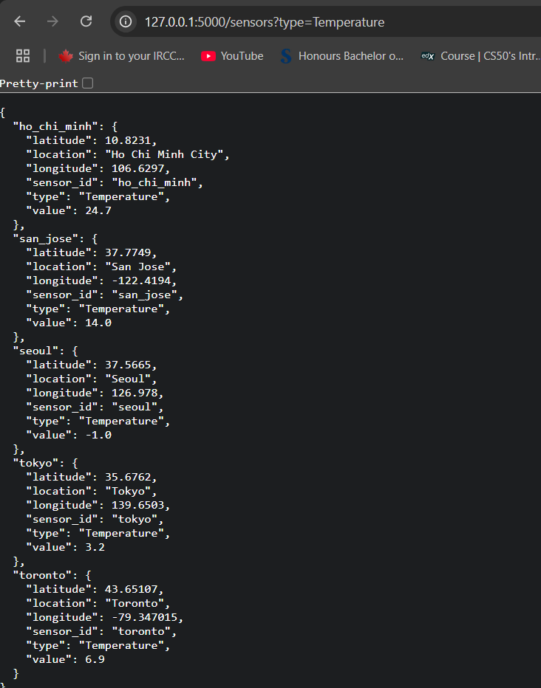
Screenshot output of code:
